Kayak Skills
Forward paddling – practise paddling around the pool.  Why not try it with a canoe paddle in your kayak?  Try forward paddling in a figure of eight. | 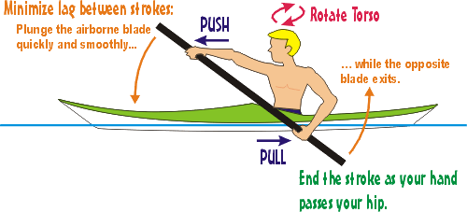 | Backwards paddling -  Practise paddling in a straight line backwards. Try paddling in a figure of 8 backwards
Stopping  How quick can you stop?  Make sure you stop in a straight line. | 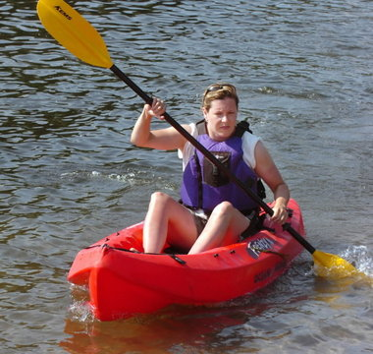 | Sweep strokes  How fast can you turn your boat round on the spot?  Can you turn all the way round with one stroke?  Try a combination of forward and backwards | 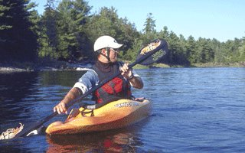
Sideways – Draw  Aim for vertical blade – the top hand should be over the water | 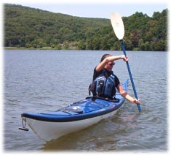 | Sideways – Sculling  Keep is smooth – can you do it without any sound | 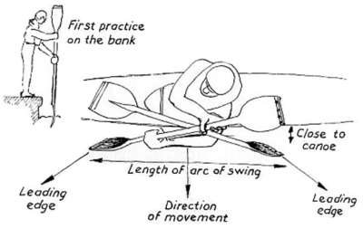
Bow draw – used to turn the boat |  | Draw stroke on the move – try to make your kayak jump sideways when paddling forward | 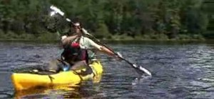
Hanging draw - get some momentum and then plant the paddle so that the water moves it sideways | 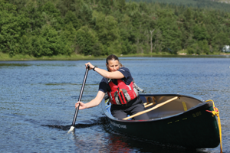 | Edging – holding the boat on an edge – how big an edge can you do before the boat capsizes. | 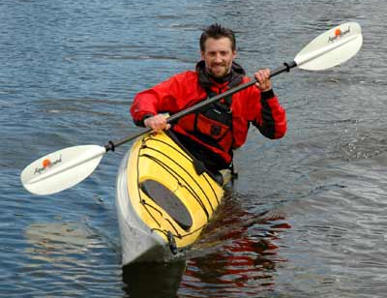
Edging – paddling on different edges  This is an essential skill as you move onto white water | 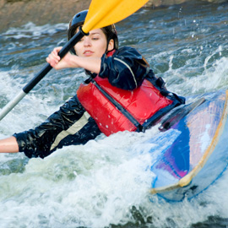 | Hip flicks- use the pool side to help | 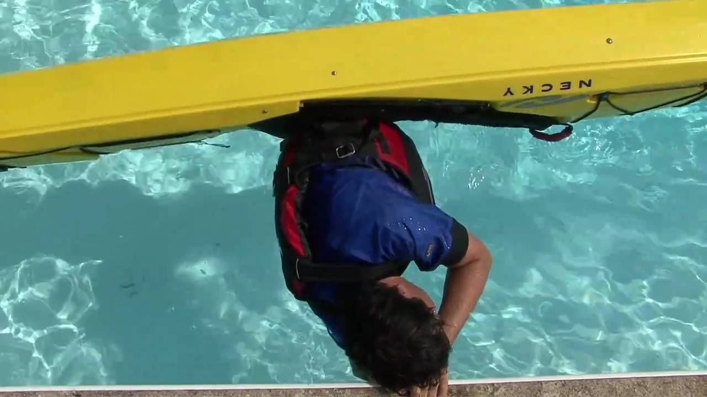
Hip flicks on someone’s hands – as little pressure as possible. Get the person supporting to grade the pressure 1-5 | 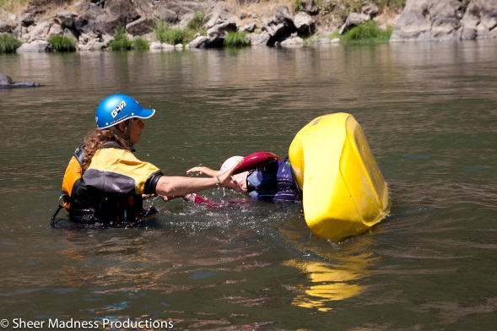 | Self rescues – capsize and swim to the side  Try with and without a spray deck | 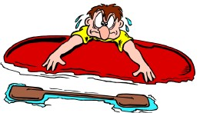
Self rescues – climbing back into the boat from deep water with no help | 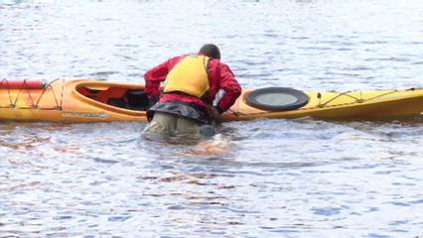 | Deep water rescues – help a swimmer back into their boat | 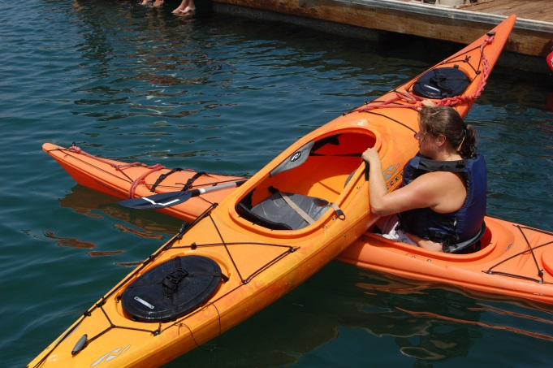
Eskimo rescues | 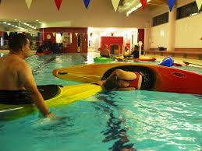 | Capsize away from side and swim upside down to side and get do hip flicks | 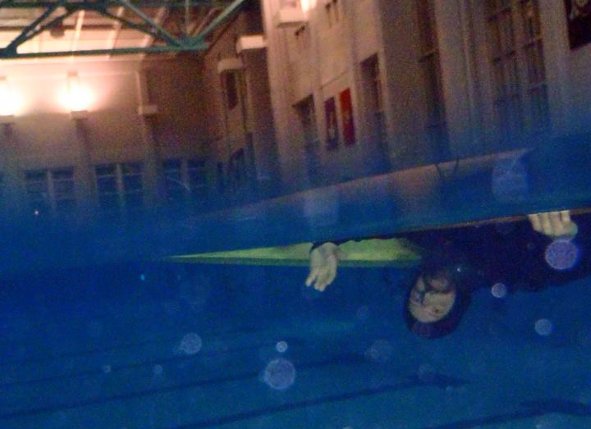
Support strokes – low brace | 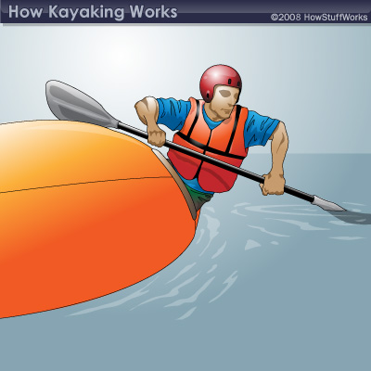 | Support strokes – high brace | 